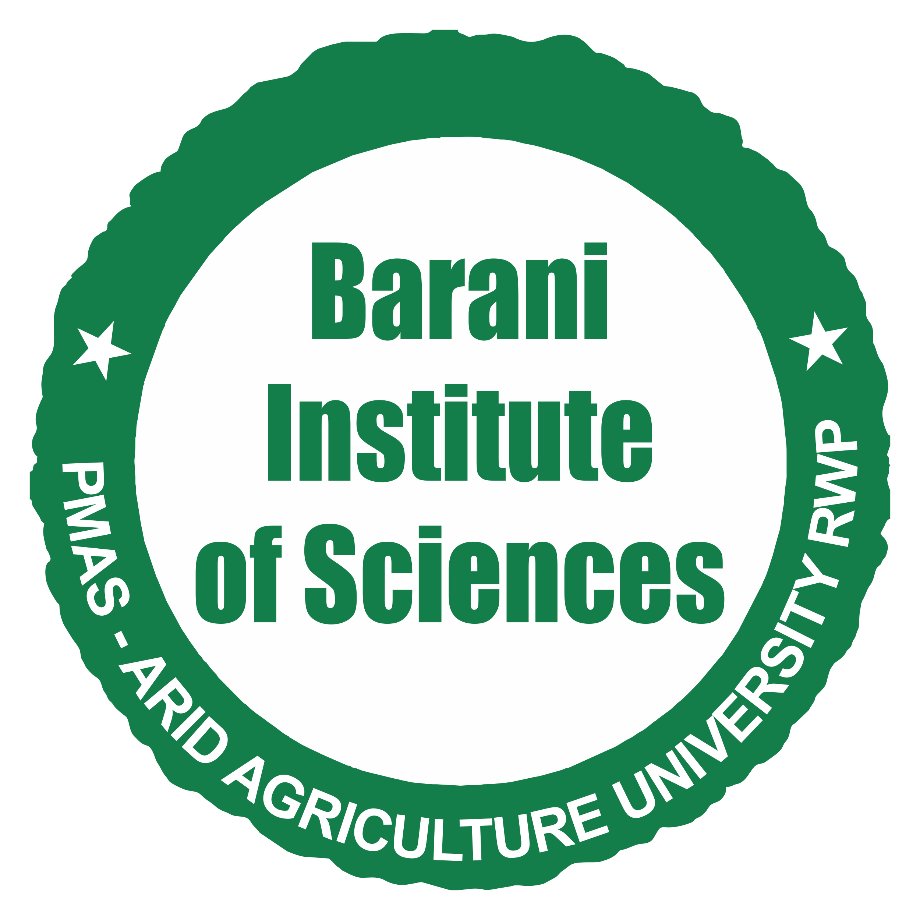


ARID UNIVERSITY-BARANI INSTITUTE OF SCIENCES

ADMISSIONS GUIDE
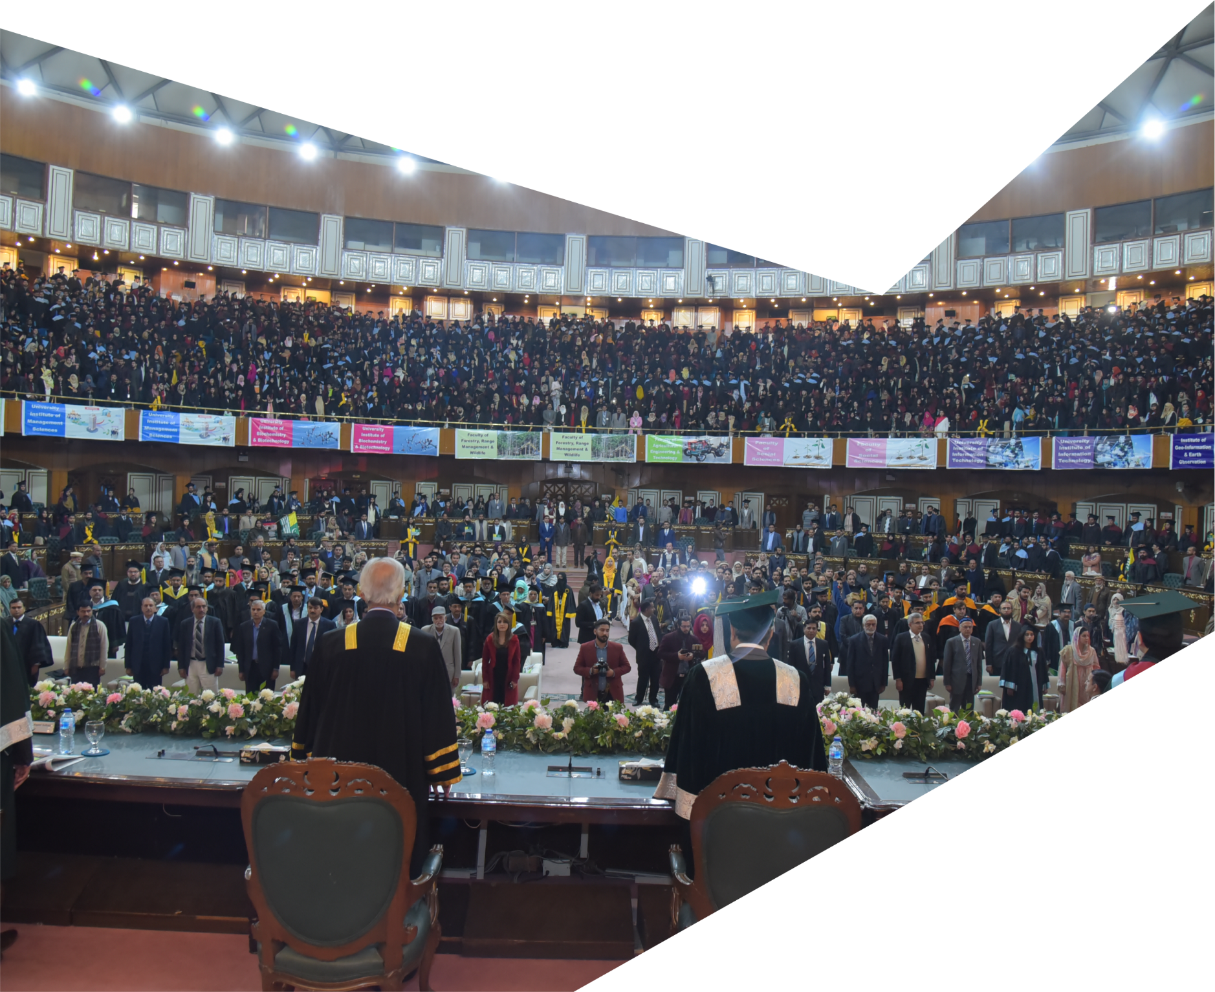

2023-24

`
I very dearly welcome you to the PMAS-Arid Agriculture University. I believe that the good quality of education imparted to the students would cause considerable prosperity to the country. Youth constitutes about seventy percent of Pakistan’s population. This reminds me of the founder of Pakistan who once said that the job of building the nation lies upon the shoulders of its youth. You are being the architects of our nation are advised to be committed to excellence in your academic and professional lives.
It is my advice to the students that it is time to control your destiny, dream big and reach the milestones in your careers. Hold on to what is right even when the odds are stacked against you. Let me tell you that a life well lived is the one you spend holding the hands of the destitute, the weak and those in need. I wish that you would embrace the lofty principles of truthfulness, integrity and patriotism. I earnestly hope that you will take decisions that embed ethics, empathy, and sincerity, for without all these societies don’t change for the better.
I wish you well.

Muhammad Baligh-ur-Rehman
Governer Punjab
LIST OF ABBREVIATIONS

BF | Barani Foundation
BOM | Board of Management
BIS | Barani Institute of Sciences
BTHP | Barani Talent Hunt Program
BMBS | Barani Merit Based Scholarships
BKS | Barani Kinship Scholarship
BGES | Barani Government Employee Scholarship
BTCS | Barani Teacher’s Children Scholarship
NBFA | Need Based Financial Assistance
BSDAS | Barani Scholarship for Differently abled Students
BNBS | Barani Need Based Scholarship
BQHS | Barani Qarz-e-Hasna Scheme
HND | Human Nutrition & Dietetics
FST | Food Sciences & Technology
MLT | Medical Lab Technology
CS | Computer Sciences
AI | Artificial Intelligence
SE | Software Engineering
BBA | Bachelors in business administration
SCHOLARSHIPS AND FINANCIAL AIDS
Barani Foundation is committed to empowering and supporting students through scholarships and financial aid programs. Recognizing the importance of education and its transformative impact, the foundation strives to create opportunities for deserving individuals who may face financial constraints. By providing scholarships and financial aid, Barani Foundation aims to enable students to pursue their academic aspirations and unlock their full potential. With a strong belief in equal access to education, the foundation endeavours to bridge the gap and ensure that talented individuals are not hindered by financial barriers. Through its dedicated efforts, Barani Foundation not only assists students in achieving their educational goals but also contributes to the development of a more equitable society.

The following Scholarships are awarded by Barani Foundation

CATEGORY-A (SCHOLARSHIPS AWARDED AT THE TIME OF ADMISSION)

1. BARANI TALENT HUNT PROGRAM (BTHP)
The Barani Foundation has taken a commendable initiative by introducing the Barani Talent Hunt Program, a platform designed to identify and nurture exceptional student talent. This program serves as a gateway for students to showcase their skills and abilities in various fields. One of the significant advantages of the Barani Talent Hunt Program is the opportunity it offers students to secure scholarships and recognizing the importance of providing financial support to deserving students, awards scholarships to those who display exceptional aptitude and potential. This initiative not only promotes healthy competition among students but also encourages them to excel in their respective areas of interest. The Barani Talent Hunt Program plays a pivotal role in empowering students by unlocking opportunities and enabling them to pursue their educational dreams while nurturing their individual talents.
Barani talent hunt program have categorized as:
- BTHP Excellence Award
- BTHP Brilliance Award
1.1 BTHP Excellence Award
Barani Foundation is dedicated to promoting academic excellence and supporting the achievements of outstanding students. As part of their commitment to recognizing and encouraging scholastic brilliance, the institute offers scholarships in the form of excellence awards. These prestigious awards are bestowed upon students who have demonstrated exceptional performance in their board exams. By rewarding the top achievers, Barani Foundation aims to motivate students to strive for excellence and set high academic standards. These scholarships not only provide financial assistance but also serve as a token of appreciation for the hard work, dedication, and commitment exhibited by the recipients. Through this program, the institute seeks to nurture and encourage a culture of academic excellence, inspiring students to reach their full potential and pursue their dreams. The excellence awards offered by Barani Institute of Sciences reflect their unwavering belief in the power of education and their commitment to empowering deserving students to succeed in their educational journey.
The details of the BTHP excellence award are given below.
Eligibility criteria:
Position holder(s) in their last degree from respective intermediate boards.
Award of Scholarship:
Fully funded scholarship
- Waiver of full fees
- Monthly stipend
- Free study material
Waiver of Fee:
The scholar will pay the admission fees at the time of submission of application, which shall be refunded to the student after approval of admission application.
Monthly Stipend:
- The scholar will get a stipend of Rs. 5,000/- per month.
- The stipend will be paid in favor of student parent/guardian.
- The BF board of management (BOM) will decide the stipend disbursement policy on case-to-case basis. (Normally, it is paid quarterly).
Free Study Material:
BF will provide the teacher’s recommended course material pack in each semester free of cost.
Policy Continuation:
- The award of scholarship is the sole discretion of BF.
- For continuation of the policy student shall maintain 3.0/4.0 or higher CGPA.
- In case of noncompliance of institute rules and regulations (discipline/student conduct), institute reserves the right to cancel the scholarship.
- 75% attendance in each course is mandatory for the continuation of scholarship.
1.2 BTHP Brilliance Award
The Barani Foundation, known for its commitment to promoting educational opportunities, offers scholarships in the form of Brilliance Awards to exceptional students. This prestigious award is a testament to the foundation's recognition and appreciation of academic excellence. By providing financial support and recognition to these high-achieving students, the Barani Foundation not only acknowledges their hard work and dedication but also encourages them to continue striving for greatness. The Brilliance Awards serve as a source of inspiration for other students, motivating them to aim for excellence in their academic pursuits. These scholarships not only alleviate the financial burden on students but also serve as a symbol of their remarkable achievements. Through the Brilliance Awards, the Barani Foundation actively contributes to the development of a society where talent and hard work are recognized, celebrated, and rewarded.

Eligibility criteria:
- 90% or above marks is last degree for (BS-Medical Lab Technology, BS-Human Nutrition & Dietetics, BS-Food Sciences & Technology, BS-Microbiology, BS-Biochemistry).
- 85% or above marks in last degree for (BS-Computer Sciences, BS-Artificial Intelligence, BS-Software Engineering, BBA (Hons.), BBA (2 Y), BS-Mathematics.
Award of Scholarship:
- 100% semester fee waiver
Waiver of Fee:
The scholar will pay the admission fees at the time of submission of application, which shall be refunded to the student after approval of admission application.
Policy Continuation:
- The award of scholarship is the sole discretion of BF.
- For continuation of the policy student shall maintain 3.0/4.0 or higher CGPA.
- In case of noncompliance of institute rules and regulations (discipline/student conduct), institute reserves the right to cancel the scholarship.
- 75% attendance in each course is mandatory for the continuation of scholarship.
2. BARANI MERIT BASE SCHOLARSHIP (BMBS)
The Barani Foundation is dedicated to supporting and recognizing deserving students based on their academic merit. Through their merit-based scholarship program, students are awarded scholarships based on the numbers they obtained in their last degree. This approach serves as a testament to the foundation's commitment to promoting and rewarding academic excellence. By linking the scholarship amount to the student's performance, the Barani Foundation not only acknowledges their hard work and achievements but also provides them with financial assistance to pursue their educational aspirations. This merit-based scholarship program acts as a source of motivation for students to strive for higher academic goals, encouraging them to perform at their best. By offering scholarships based on merit, the Barani Foundation fosters a culture of excellence, where students are encouraged to work hard and excel in their studies. Through their initiatives, the foundation demonstrates its commitment to supporting and empowering students, enabling them to reach their full potential and contribute to society.
MERIT SCHOLARSHIP CRITERIA FOR BS-HND & BS-FST PROGRAMS
Sr.# | Percentage Marks in Last Degree | Scholarship
1 | 85%-89.99% | 50%
2 | 80%-84.99% | 40%
3 | 70%-79.99% | 30%
4 | 60%-69.99% | 20%
5 | 50%-59.99% | 10%
MERIT SCHOLARSHIP CRITERIA FOR BS-MLT PROGRAMS
Sr.# | Percentage Marks in Last Degree | Scholarship
1 | 85%-89.99% | 55%
2 | 80%-84.99% | 45%
3 | 70%-79.99% | 30%
4 | 60%-69.99% | 20%
5 | 50%-59.99% | 10%
MERIT SCHOLARSHIP CRITERIA FOR BS-Microbiology & BS-Biochemistry
Sr.# | Percentage Marks in Last Degree | Scholarship
1 | 85%-89.99% | 50%
2 | 80%-84.99% | 45%
3 | 70%-79.99% | 40%
4 | 60%-69.99% | 30%
5 | 50%-59.99% | 20%
MERIT SCHOLARSHIP CRITERIA FOR BSCS(G), BSCS (AI) and BS (SE)
Sr.# | Percentage Marks in Last Degree | Scholarship
1 | 80%-84.99% | 55%
2 | 70%-79.99% | 45%
3 | 60%-69.99% | 35%
4 | 50%-59.99% | 25%

MERIT SCHOLARSHIP CRITERIA FOR BS-MATH Programs
Sr.# | Percentage Marks in Last Degree | Scholarship
1 | 80%-84.99% | 60%
2 | 70%-79.99% | 50%
3 | 60%-69.99% | 40%
4 | 50%-59.99% | 30%

MERIT SCHOLARSHIP CRITERIA FOR BBA (Hons.)
Sr.# | Percentage Marks in Last Degree | Scholarship
1 | 80%-84.99% | 55%
2 | 70%-79.99% | 45%
3 | 60%-69.99% | 35%
4 | 50%-59.99% | 25%
MERIT SCHOLARSHIP CRITERIA FOR BBA 2 Y Programs
Sr.# | Percentage Marks in Last Degree | Scholarship
1 | 80%-84.99% | 35%
2 | 70%-79.99% | 30%
3 | 60%-69.99% | 25%
4 | 50%-59.99% | 20%

Policy Continuation:
- The award of scholarship is the sole discretion of BF.
- For continuation of the policy student shall maintain 2.5/4.0 or higher CGPA.
- In case of noncompliance of institute rules and regulations (discipline/student conduct), institute reserves the right to cancel the scholarship.
- 75% attendance in each course is mandatory for the continuation of scholarship.
3. BARANI KINSHIP SCHOLARSHIP (BKS)
The Barani Foundation is dedicated to supporting students through a wide range of scholarship opportunities, including kinship scholarships. Recognizing the importance of family and community, the foundation understands that financial constraints should not hinder educational aspirations within kinship relationships. These scholarships not only alleviate the financial burden but also promote the value of education across generations. The Barani Foundation's commitment to kinship scholarships demonstrates their belief in the power of family support and their dedication to empowering students to achieve their educational goals within the framework of their familial relationships. In case of two or more siblings are the students, all of the siblings get the scholarship except the first one. The kinship scholarship does not apply to cousins or relatives.
Application is required to be submitted to the office of Students Affairs. The Assistant Director of Students affairs will verify the application form.
The scheme will cover the siblings in the following categories.
Scholarship Category | Eligibility | Award of Scholarship
Kinship Scheme | Two or more siblings concurrently students of | 50% waiver in tuition fee of siblings
Kinship Scheme | Main campus student | 35% waiver in tuition fee of siblings
Policy Continuation:
- The award of scholarship is the sole discretion of BF.
- In case of noncompliance of institute rules and regulation (discipline/student conduct), the institute reserves the right to cancel the scholarship.
- 75% attendance in each course is mandatory for the continuation of scholarship.
- For continuation of the policy student must maintain 2.5/4.0 or higher CGPA.
4. BARANI GOVERNMENT EMPLOYEE SCHOLARSHIP (BGES)
The Barani Foundation recognizes the significant contributions made by government employees and their families to the betterment of society. To support and honour their dedication, the foundation offers scholarships specifically tailored for government employees. These scholarships provide financial assistance to the dependents of government employees. By providing these specialized scholarships, the Barani Foundation aims to alleviate the financial burden of education and promote the pursuit of higher education among government employees and their families. This initiative not only recognizes the value of public service but also encourages the continuous growth and development of individuals associated with the government sector. The Barani Foundation's provision of government employee scholarships underscores their commitment to empowering those who serve the public and their commitment to fostering educational opportunities for individuals connected to the government sector.
The Barani Foundation (BF) is offering scholarships to the children of the in service, retired or late employees of Government. Application in this regard should be submitted to the office of student’s affairs.
Award of Scholarship:
- The student will be promoted to the next higher slab in merit scholarship in case of government employee.
- The award of scholarship is for the complete degree program.
Policy Continuation:
- The award of scholarship is the sole discretion of BF.
- In case of noncompliance of institute rules and regulation (discipline/student conduct), the institute reserves the right to cancel the scholarship.
- 75% attendance in each course is mandatory for the continuation of scholarship.
- For continuation of the policy student must maintain 2.5/4.0 or higher CGPA.

5. BARANI TEACHER’S CHILDERN SCHOLARSHIP (BTCS)
The Barani Foundation recognizes the invaluable role that teachers play in shaping the minds and futures of students. In appreciation of their dedication and service, the foundation provides scholarships specifically designed for the children of teachers. These scholarships aim to support and empower the next generation of learners, enabling them to pursue their educational aspirations. By offering financial assistance to the children of teachers, the Barani Foundation acknowledges the commitment and sacrifices made by educators and seeks to alleviate the financial burden of higher education. These scholarships not only recognize the impact that teachers have on society but also encourage the continuation of a legacy of education within their families. The Barani Foundation's provision of scholarships for the children of teachers reflects their deep appreciation for the teaching profession and their commitment to nurturing and supporting the educational journeys of future generations.
Application in this regard should be submitted to the office of student’s affairs.
Award of Scholarship:
- Extra 10% scholarship in tuition fee will be granted.
- The award of scholarship is for the complete degree program.
Policy Continuation:
- The award of scholarship is the sole discretion of BF.
- In case of noncompliance of institute rules and regulation (discipline/student conduct), the institute reserves the right to cancel the scholarship.
- 75% attendance in each course is mandatory for the continuation of scholarship.
- For continuation of the policy student must maintain 2.5/4.0 or higher CGPA.

6. AMAN SCHOLARSHIP (SAHIWAL POLICE)
The Barani Foundation has taken a commendable initiative by offering scholarships to the Sahiwal Police. This generous gesture aims to recognize and support the hard work and dedication exhibited by the police force in ensuring the safety and security of the Sahiwal community. The scholarships provided by the Barani Foundation will enable deserving police personnel to pursue higher education and enhance their professional skills. By investing in the education of the police force, the foundation not only empowers individuals but also contributes to the overall development and effectiveness of the Sahiwal Police. This collaborative effort between the Barani Foundation and the Sahiwal Police is a testament to their shared commitment to building a brighter future for the community.
Application in this regard should be submitted to the office of student’s affairs.

Award of Scholarship:
- 100% fee waiver for the children of Shauda of Sahiwal police.
- 50% scholarship will be given in tuition fee.
- 50% scholarship will be given in admission fee.
- The award of scholarship is for the whole degree program.
Policy Continuation:
- The award of scholarship is the sole discretion of BF.
- In case of noncompliance of institute rules and regulation (discipline/student conduct), the institute reserves the right to cancel the scholarship.
- 75% attendance in each course is mandatory for the continuation of scholarship.
- For continuation of the policy student must maintain 2.5/4.0 or higher CGPA.
7. Nation Builders Scholarship (Regional Tax Office Sahiwal)
The Barani Foundation has undertaken a commendable initiative by offering scholarships to the children of the officers/officials of Regional Tax Office Sahiwal. This substantial action aims to recognize and support the hard work and dedication exhibited by the employees of the Regional Tax Office Sahiwal in their vital role for the prosper economy of the country. These scholarships, made possible by the Barani Foundation, will empower children of the officers/officials of the Regional Tax Office Sahiwal to pursue higher education and enhance their professional skills.

Barani Foundation not only uplifts individuals but also significantly contributes to the overall development to the society at large. This collaborative endeavour between the Barani Foundation and the Regional Tax Office Sahiwal underscores their shared commitment to build a brighter future for the children of the officers/officials. It serves as a testament to their dedication to education and their belief that a well-educated workforce is crucial for the continued progress and prosperity of the region.

Application in this regard should be submitted to the office of student’s affairs.

Award of Scholarship:
- 50% scholarship will be given in tuition fee.
- 50% scholarship will be given in admission fee.
- The award of scholarship is for the whole degree program.

Policy Continuation:
- The award of scholarship is the sole discretion of BF.
- In case of noncompliance of institute rules and regulation (discipline/student conduct), the institute reserves the right to cancel the scholarship.
- 75% attendance in each course is mandatory for the continuation of scholarship.
- For continuation of the policy student must maintain 2.5/4.0 or higher CGPA.
CATEGORY-B (SCHOLARSHIPS AWARDED DURING STUDY)

1. NEED BASED FINANCIAL ASSISTANCE (NBFA)
The barani foundation is dedicated to providing quality education to everyone who has the ability to strive ahead. scholarships and financial aid are the vital tools for helping students in affording a world-class education, setting them on the part of progress. The Barani Foundation (BF) has a dedicated and caring financial aid team for bringing affordable education to the doorstep of every deserving student. From need-based programs to merit scholarships for each outstanding individual student, a wide range of options is available for everyone. In addition, with our commitment to economic diversity, generous financial aid programs and a resourceful financial aid office, the institute ensures the removal of obstacles sin the students journey here. Applications are required to be submitted to the office of student’s affairs. The assistant director of students’ affairs will verify the application form.
NBFA covers the following categories.
- Barani Foundation Education Insurance (BFEI)
- Disable Student
- Needy Student
1.1 BARANI FOUNDATION EDUCATION INSURANCE (BFEI)
Every student who is registered with the BIS is covered under BFEI during his/her studies. In case of guardian(father) death during studies, Barani Foundation shall bear semester fee of remaining program at BIS.
Sr.# | Types | Scholarship
1 | In case of Guardian (Father) Death | 100% semester fee waived off for the remaining semesters
2 | In case of Guadian (Father) Disability | 50% semester fee waived off for the remaining semesters

- The award of scholarship is the sole discretion of BF.
- In case of noncompliance of institute rules and regulation (discipline/student conduct), the institute reserves the right to cancel the scholarship.
- 75% attendance in each course is mandatory for the continuation of scholarship.
- For continuation of the policy student must maintain 2.5/4.0 or higher CGPA.

1.2 BARANI SCHOLARSHIPS FOR DIFFERENTLY ABLED STUDENTS (BSDAS)
Disability is an umbrella term. Covering impairments, activity limitations, and participation restrictions. An impairment is a problem in body function or structure, impairments causing disability may be present from birth or occur during a person lifeline; an activity limitation is a difficulty encountered by an individual in involvement in the life situations. Disability is thus not just a health problem, it is a complex phenomenon, reflecting the interaction between features of a person’s body and features of the society in which he or she lives. Barani Foundation also support disable students in this regard to complete their education without any hurdles.
The application forms for the scholarships are available at the office of the student’s affairs office and the student must submit the form within two weeks of commencement of their first-semester classes. The financial assistance committee awards scholarships based on interviews with the applicants, and a thorough evaluation of applications.
Award of Scholarship:
- Financial assistance will be provided up to Rs. 10,000/- to deserving students per semester.
- The award of scholarship is for the whole degree program.
Policy Continuation:
- The award of scholarship is the sole discretion of BF.
- In case of noncompliance of institute rules and regulation (discipline/student conduct), the institute reserves the right to cancel the scholarship.
- 75% attendance in each course is mandatory for the continuation of scholarship.
- For continuation of the policy student must maintain 2.5/4.0 or higher CGPA.
1.3 BARANI NEED BASED SCHOLARSHIP (BNBS)
Need-based scholarships at the BIS ensure that no student financial circumstances keep them from pursuing their education. The scholarships are available to all incoming students. The application forms for the scholarships at the student’s affairs office, and aspiring students must submit the form within the two weeks of commencement of their first-semester classes. The financial assistance committee awards scholarships based on interviews with the applicants, and a thorough evaluation of applications. The financial assistance committee ensures that every application is carefully analyzed, and the decision-making process is exhaustive and transparent.
Award of Scholarship:
- Financial assistance will be provided up to Rs. 10,000/- to financially deserving students per semester.
- The award of scholarship is for the whole degree program.
Policy Continuation:
- The award of scholarship is the sole discretion of BF.
- In case of noncompliance of institute rules and regulation (discipline/student conduct), the institute reserves the right to cancel the scholarship.
- 75% attendance in each course is mandatory for the continuation of scholarship.
- For continuation of the policy student must maintain 2.5/4.0 or higher CGPA.

2. BARANI QARZ-E-HASNA SCHEME (BQHS)
Qarz-e-hasna scheme introduced at Barani Institute of Sciences (BIS) from Fall-2014 with an objective to financially support students belonging to less privileged class of society. Through this scheme the institute will bear the educational expenses of the students on “Need cum merit” basis in order to enable them to complete their higher education.
Eligibility Criteria:
Following are the eligibility criteria to apply for Qarz-e-hasna scheme.
- Students cannot apply for Qarz-e-Hasna in the first semester.
- For the students enrolled in the2nd semester onwards shall be eligible to apply if has a minimum 3.0 GPA/CGPA in the previous semester. For continuation student should maintain at least 3.0 GPA/CGPA; otherwise, his/her qarz-e-hasna shall be withheld till the time he/she improve academic grades to 3.0 GPA/CGPA.
- At a time, students can avail only one option either scholarship or free concession or qarz-e-hasna from institute or external sources. If a student falls under more than one category, then he/she may avail any option as per his/her own discretion.
Approvals and Limits:
- The Qarz-e-Hasna shall be awarded, partly or fully against the tuition fee.
Repayment:
- All successful applicants must sign an agreement, including a repayment schedule.
- The repayment schedule must be structured well as to allow full loan repayment once the students have graduated or financially stable. The maximum repayment duration must not exceed 02 years.
- At the time of passing out of the student, the institute will provide him/her the repayment plan specifying the cut-off date by which the student has to clear his/her total due amount, in lump sum or installments.
- It’s a moral responsibility of every recipient to pay back the received Qarz-e-hasna amount within the stipulated time period so that maximum deserving students can benefit from this policy.
Guarantors:
- Students have to provide two guarantors.

Agreement with student & guarantor:
Once the final approval is accorded, an agreement shall be signed between the student with the guarantee of his/her parents or spouse (in case of married student) and the institute.
- Qarz-e-Hasna (interest free loan) will be granted to five students in each academic year.
Undergraduate: | 03 Students | Postgraduate | 02 Students
- The allocation of scheme is as follows.

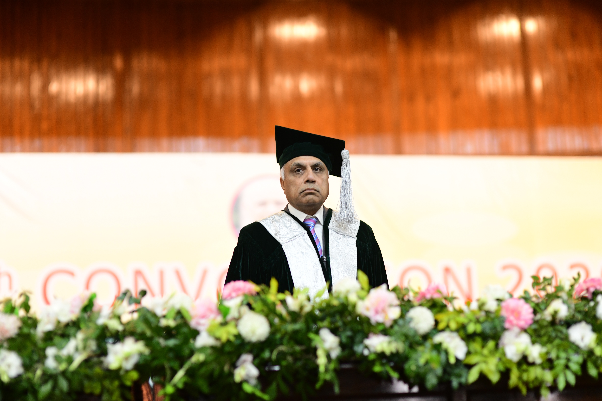
The PMAS-Arid Agriculture University is a premier public sector university of international repute. Its JV campus at Sahiwal is wonderful for the students in the area who cannot travel to bigger cities for quality education. The Barani Institute of Sciences at Sahiwal has contributed to the nation by providing quality education to the youth of the area. The graduates of this institute are already making this institute proud by working at reputed firms of the country including multinational companies.
The Barani Institute aims to keep the quality standards at level of Pakistan’s reputed educational institutions. You, by choosing this institute has made a right decision toward a brilliant academic and professional excellence.
I warmly welcome you.

Prof. Dr. QAMAR-UZ-ZAMAN
Vice Chancellor
PMAS-Arid Agriculture University
Rawalpindi
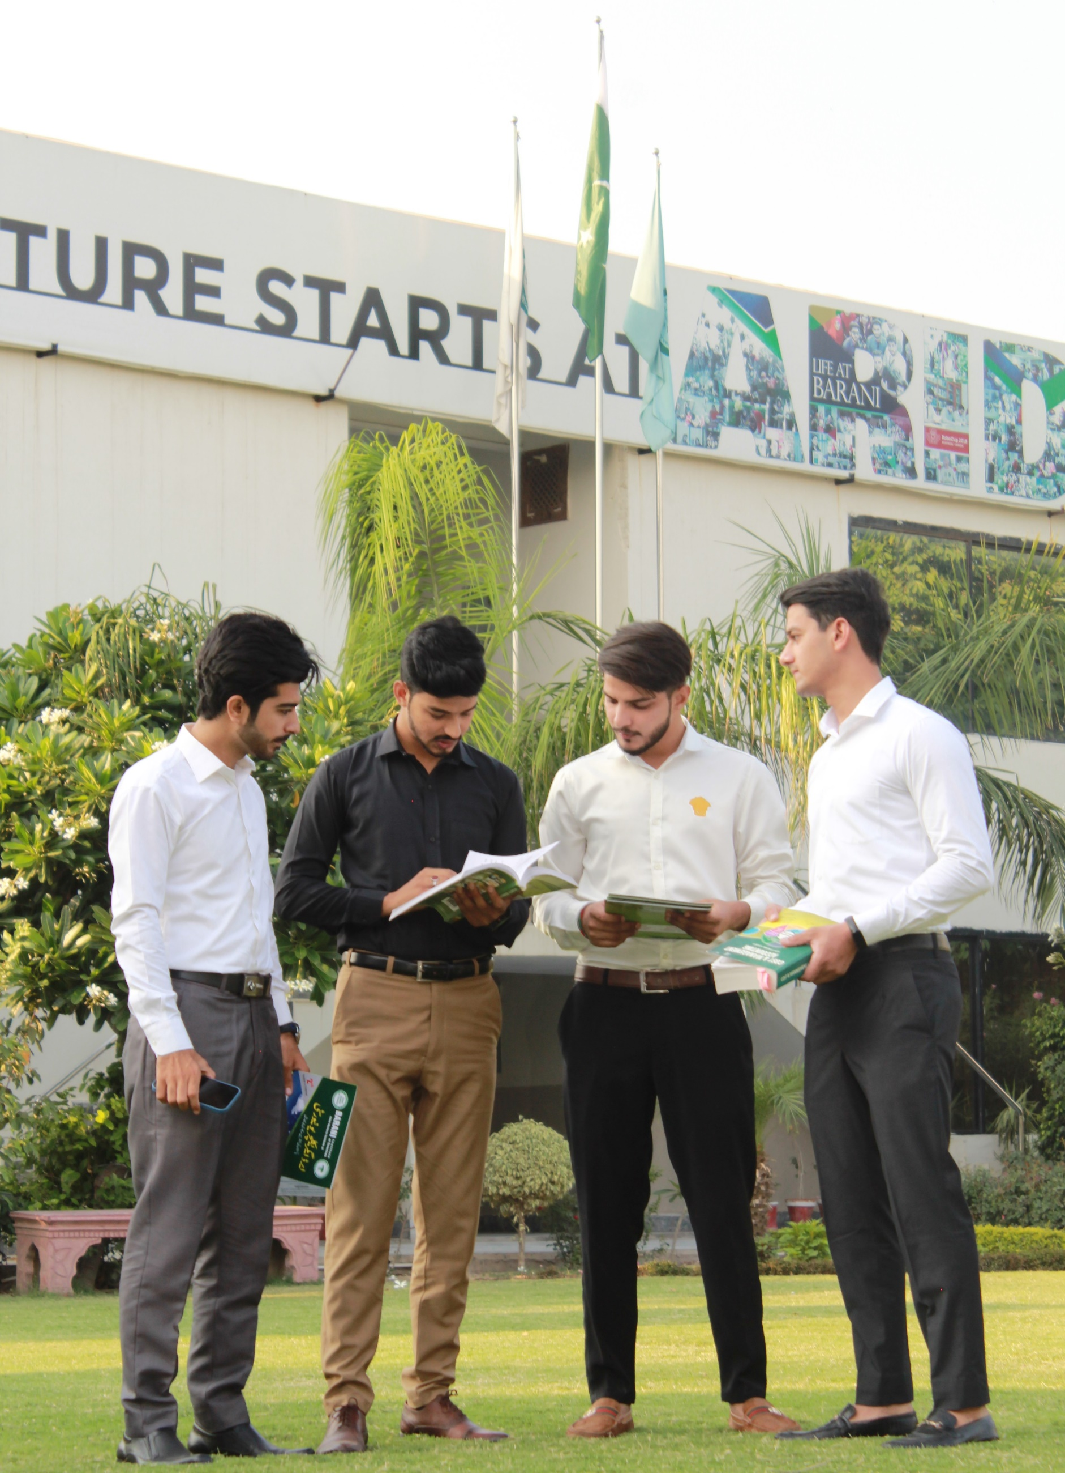
Jail Road, Sahiwal 0335-111 83 83 www.baraniinstiutue.edu.pk

